Exam computational biology 2024

11-04-2024 09.00 -11.30am
Instructions
Welcome to the computational biology exam. You are free to use the reader, slides, your notes, and whatever else you need. Be sure that your answers are clear and written down in a different font colour than the questions. You have 2.5 hours. If you find yourself spending a lot of time on one question, make sure to move on and take enough time to look at later questions as well, and then come back afterwards! Each subquestion (marked with letter a, b, …) is worth 1 point. Finally, you should write down your student number right here, and your name at the end of this document on a separate page. Do this now! In this way, we can be blinded to your names when grading the exams. Save your work throughout the exam!
When you are done
Save your file as YOURSTUDENTNUMBERHERE_ExamCompBio2024.odt and export it as YOURSTUDENTNUMBERHERE_ExamCompBio2024.pdf. Send both of these files by mail to p.hogeweg@uu.nl; m.g.c.m.zwerink@uu.nl; a.zania@students.uu.nl
Student number:

1 Replicator Dynamics
Consider the following model of 2 replicators.
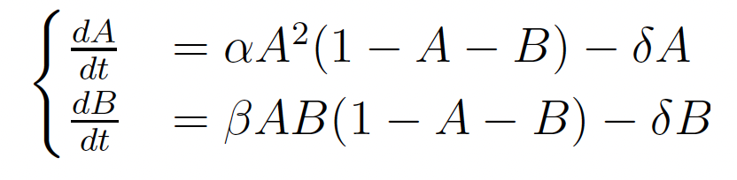

- Verbalize the interaction between the species.
YOUR ANSWER HERE
- Under which parameter conditions will both species survive?
YOUR ANSWER HERE
- Formulate a simple CA model for which the above equations are the mean field approximation (only the next state function, using pseudocode, has to be specified).
YOUR ANSWER HERE
The following pictures show snapshots of a CA model for which the equations above are a mean field approximation. They differ with respect to parameter beta.
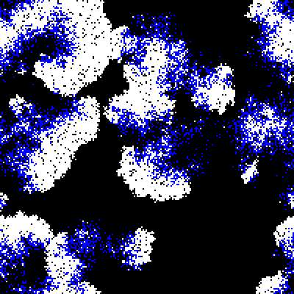
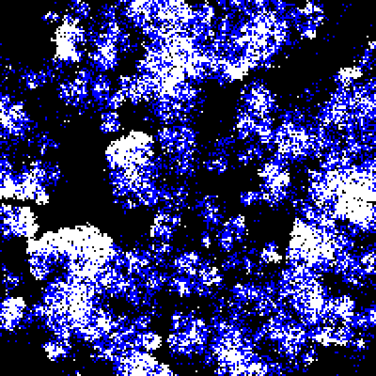

- In which picture is this parameter larger? How can you see that?
YOUR ANSWER HERE

2. Statements
Consider the following statements. Discuss (to what extent) they are true of false (or both), WHEN and WHY and illustrate your answer with examples/counterexamples discussed in the course (the answer can be of the form true if..." but then needs a follow up “Not true if..." with explanation of both)
- Higher mutation rates lead always to greater variability in a replicating system.
YOUR ANSWER HER
- The information threshold more severely limits the accumulation of information than the maintenance of information once a high-fitness solution has evolved.
YOUR ANSWER HERE
- Observed trade-offs between growth-rate and yield, are based on basic physical/chemical constraints and should be explicitly incorporated in growth and competition models.
YOUR ANSWER HERE
- Both from the fossil record and in evolutionary models we see often stepwise changes (periods of stasis and abrupt changes). This falsifies the assumption of a molecular clock (i.e. constant rate of mutation accumulation).
YOUR ANSWER HERE
- Whenever there is a redundant genotype to phenotype mapping, neutral evolution will facilitate adaptive evolution (how/why/why not).
YOUR ANSWER HERE

3. “Survival of the fittest”
Survival of the fittest is often used as a short characterization of Darwinian evolution. The concept fitness has haunted evolutionary theory. Use models discussed in the course to answer the questions below.
- Is “survival of the fittest” a tautology? (explain why/why not)
YOUR ANSWER HERE
- How can we determine who is the “fittest” in eco-evolutionary models in which no fitness is a priori defined.
YOUR ANSWER HERE
- Discuss your answer in b in the light of the following quote of Darwin:
“It is not the strongest of the species that survives,
nor the most intelligent but the one most responsive to change.”
YOUR ANSWER HERE

4. Modelling biological systems (and their evolution)
“Biological systems are distinguishable from chemical systems because they
contain components that have many potential alternative compositions but
adopt a particular composition based on the history of the system. In this
sense biological systems have a molecular memory (genotype), which is shaped
by experience (selection) and maintained by self-reproduction"
Joyce (2012) - Bit by Bit: The Darwinian Basis of Life
- Given this definition, do RP systems models (e.g. the model of question 1) represent a biological system?
YOUR ANSWER HERE
- How were evolutionary models (e.g. the RP model) modified to model a biological system as defined above? Explain one such model.
YOUR ANSWER HERE
- Evolutionary models which do qualify to the above definition, reveal new phenomena of biological evolution. Which one(s)? (Mention at least one which you think is most important)
YOUR ANSWER HERE
- Explain a second model which qualifies to the above definition and how it shows novel phenomena.
YOUR ANSWER HERE
- Explain evidence of these phenomena in biological systems (explain an experiment showing it).
YOUR ANSWER HERE
- Explain a second experiment showing it.
YOUR ANSWER HERE

5. Conflict in multilevel evolution
Multilevel evolution is recognized as such (e.g. by Maynard Smith and Szathmary in their book Major Transitions in Evolution) because of conflict between levels.
Indeed, conflict resolution appears as a major force in evolution leading to major transitions and the complex biological systems we see today.
Explain one example of conflict resolution leading to a major transition in evolution, how it was modelled, its functionality and generality.

Your name:

